**DAILY ONLINE ACTIVITIES SUMMARY**

|  |  |  |  |  |  |  |
| --- | --- | --- | --- | --- | --- | --- |
| **Date:** | **26-05-2020** | | | **Name:** | **Latika Kavoor** | |
| **Sem & Sec** | **4th Sem & A-Section** | | | **USN:** | **4AL18CS035** | |
| **Online Test Summary** | | | | | | |
| **Subject** | | **DAA** | | | | |
| **Max. Marks** | | **30** | | **Score** | **25** | |
| **Certification Course Summary** | | | | | | |
| **Course** | **Introduction to Cyber Security** | | | | | |
| **Certificate Provider** | | | **ICT Academy - CISCO** | **Duration** | | **30 hrs** |
| **Coding Challenges** | | | | | | |
| **Problem Statement:** Write a program in C to print all permutations of a given string using pointers. | | | | | | |
| **Status:Completed** | | | | | | |
| **Uploaded the report in Github** | | | | **Yes** | | |
| **If yes Repository name** | | | | <https://github.com/alvas-education-foundation/latika.kavoor/blob/master/coding_solutions/permutation.txt> | | |
| **Uploaded the report in slack** | | | | **Yes** | | |

Online Test Details: (Attach the snapshot and briefly write the report for the same)

Took the online test on 26-05-2020 from 9:15 to 10:00

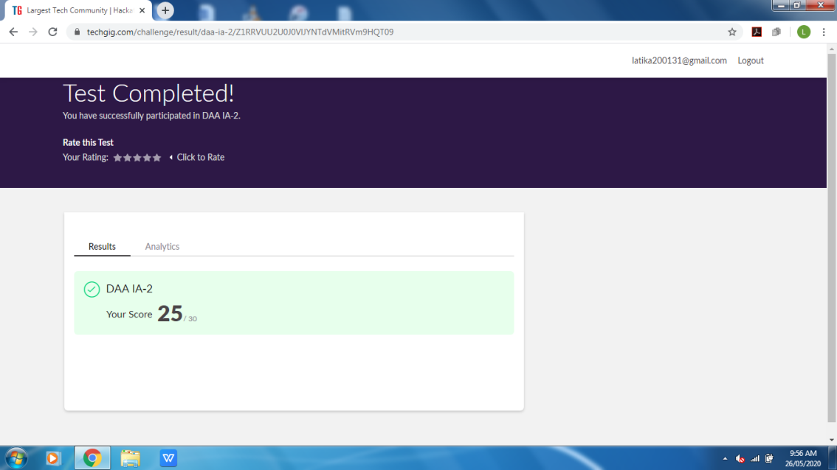

Certification Course Details: (Attach the snapshot and briefly write the report for the same)

Completing the chapter 1 of Cyber security essentials

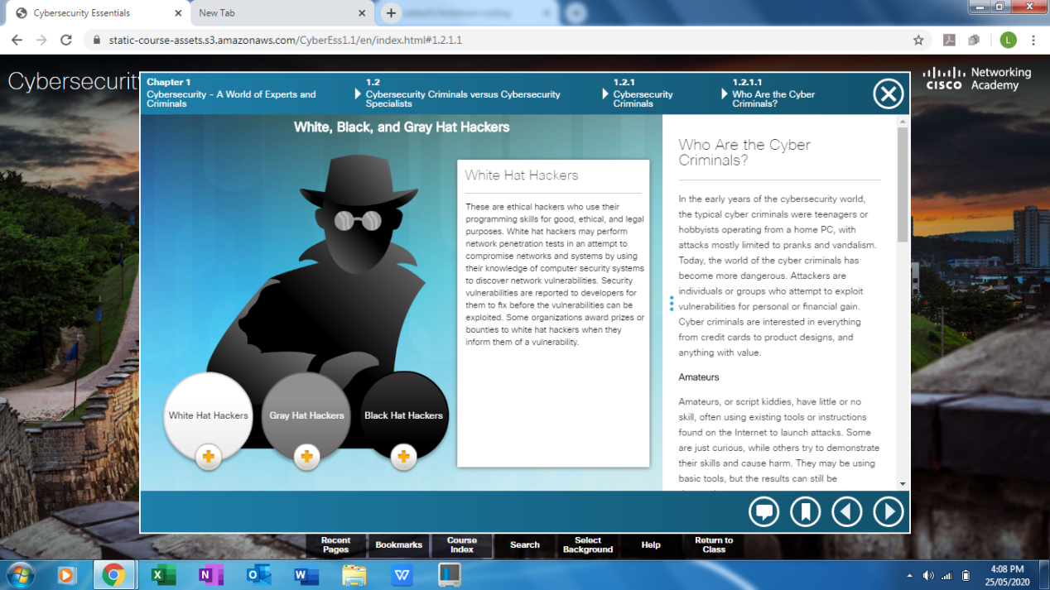

Coding Challenges Details: (Attach the snapshot and briefly write the report for the same)

Solved the problem given and uploaded on github

